**Report on User Interface in Eclipse**

**Mohammed Faiyaz Hussain**

**ST20155999**

**Module Title:** **CIS4003 Principles of Programming**

**Module Leader: Wai-Keung Fung**

**Introduction**

This report will consist of how the assignment was conducted and developed through using eclipse IDE Java edition which will then consist screenshots of the Graphical User Interface (GUI) that was created for primary school students. In addition, the GUI includes three navigational buttons that helps the student easily navigate through the interface, the three aspects include:

* Browse websites
  + Type in URL and visit the web page (created using HTML)
  + Go backwards and forwards through the pages visited during that session
  + Refresh a web page
* Perform simple arithmetic sums (Calculator)
* Adding
* Dividing
* Subtracting
* Multiplication
* Writing (Text Editor)
* Writing simple passages of text
* Change fonts and text size
* Change font colour
* Save and open text documents (.txt files)

These three aspects were enabled for the user (Key Stage 1 pupil) to go through the GUI. Furthermore, under the titles below, Design Process and methodology, it will go through how it was created, what codes were used and why it was made in this way.

**Design Process**

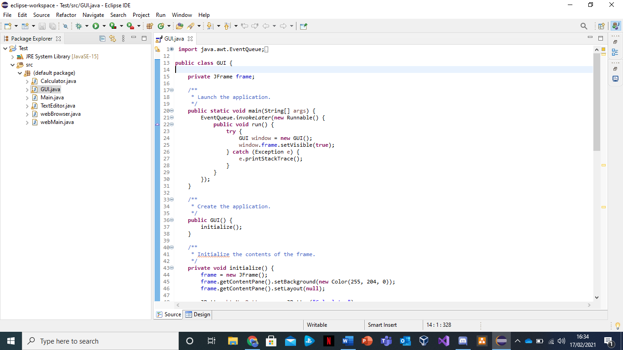Firstly, I am going to show and go through the ‘GUI’ which will then include in the screenshots below, what codes and commands were used to create and how it works.

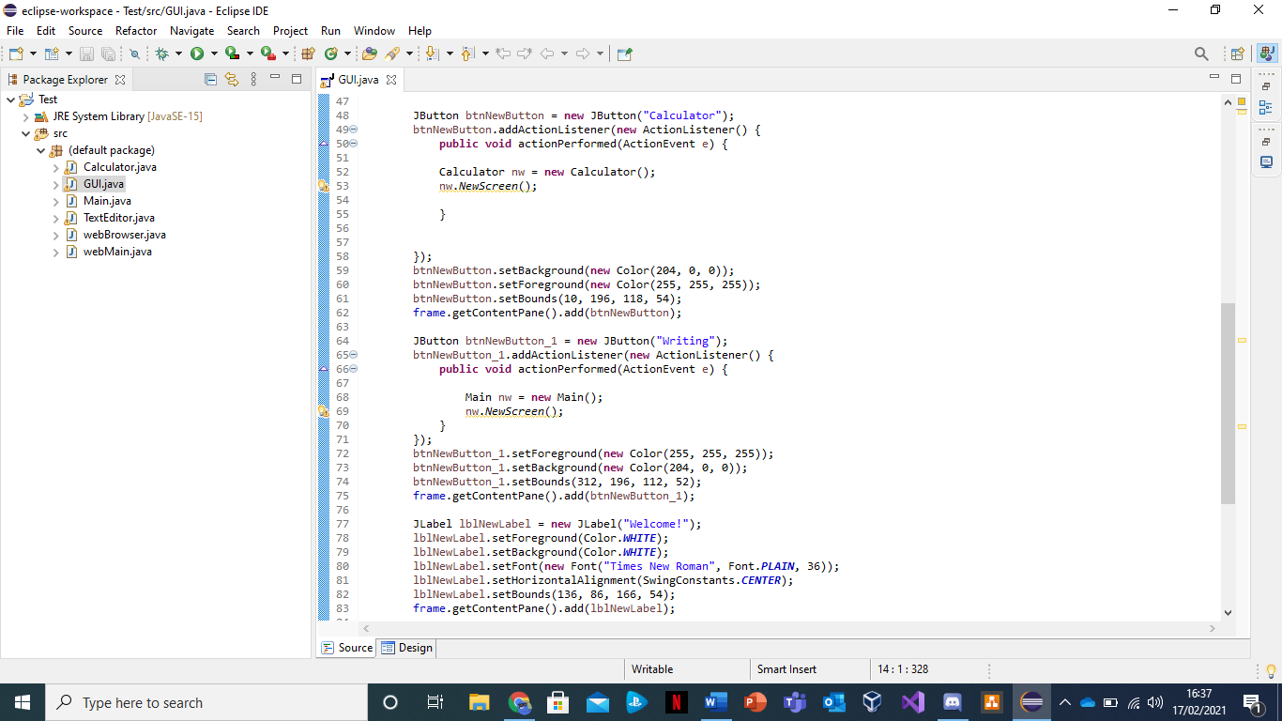

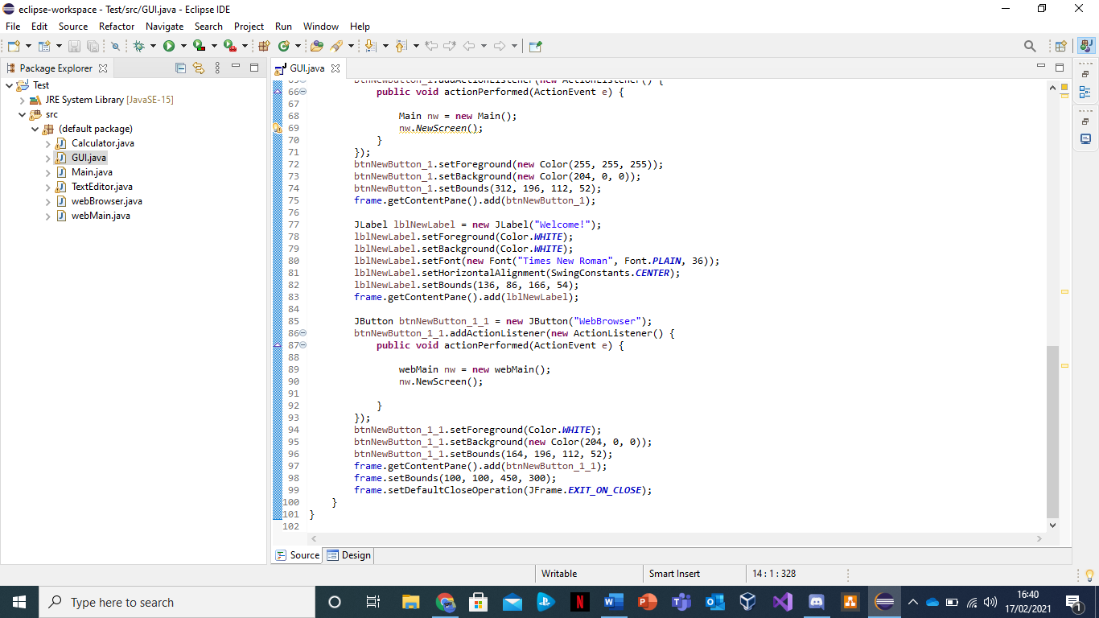

In addition to this, the GUI was created through using an application window, as you can see here the code starts off with ‘Public Class GUI’ and ‘Private JFrame frame;’ to create the layout of it. And to launch the application by using the commands ‘public static void main(String[] args)’ and ‘Public void run()’. As well as creating the application by writing and using the command; ‘public GUI () {initialize ();}’.

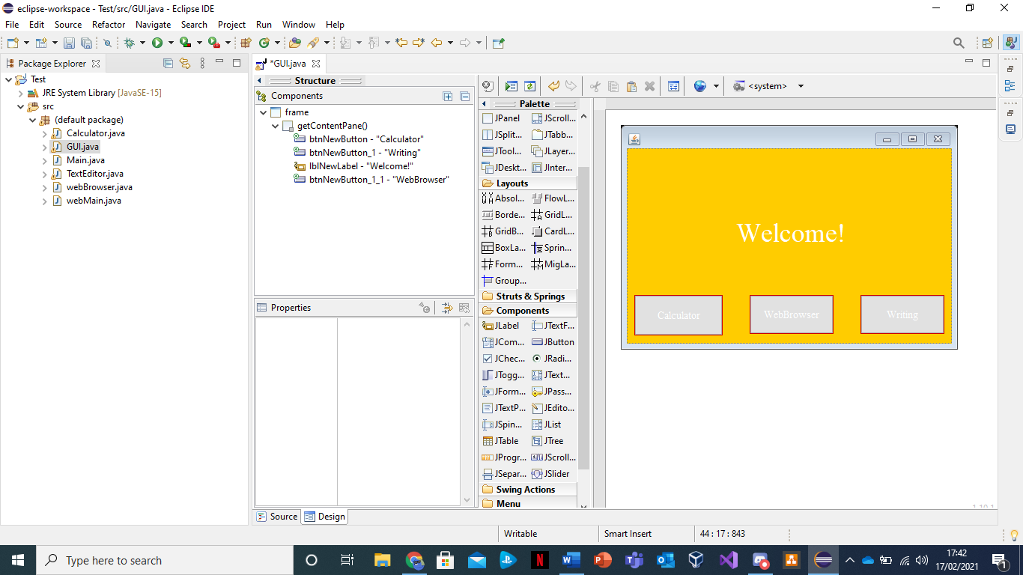Here you can see the design of the GUI, the theme and colour scheme of it is mainly yellow, red, and white. Also, the font type used is ‘Times New Roman’ as it is child friendly and it is the most commonly used one among key stage 1 students. The font size for the ‘Welcome!’ titles is ‘41’ and the size for the navigational buttons are ‘14’, the reason for this is that it is easier for them to read it. In the screenshot below, you see that the mouse is hovering over a green button which is labelled as ‘run’. As soon as you click it the final piece comes up.

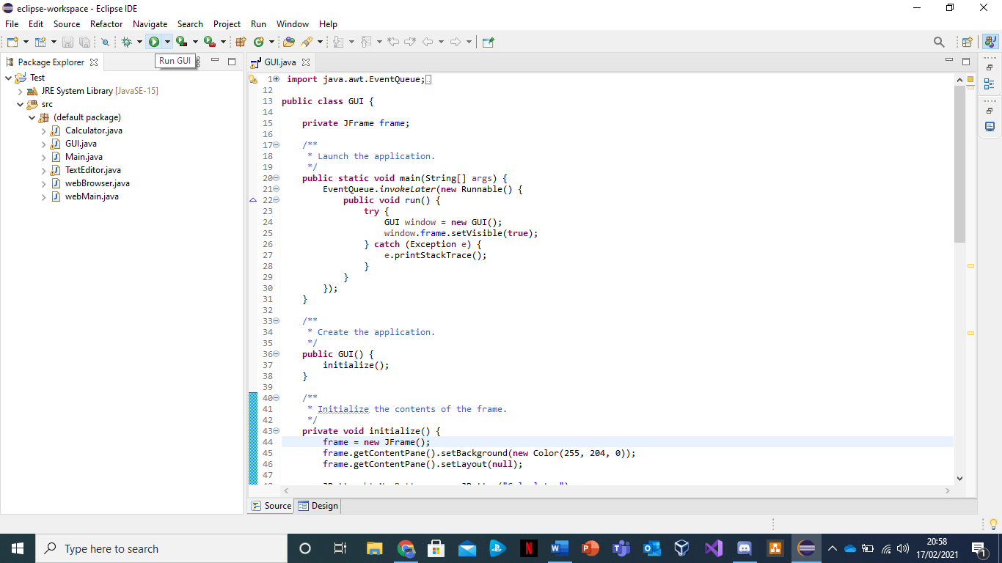

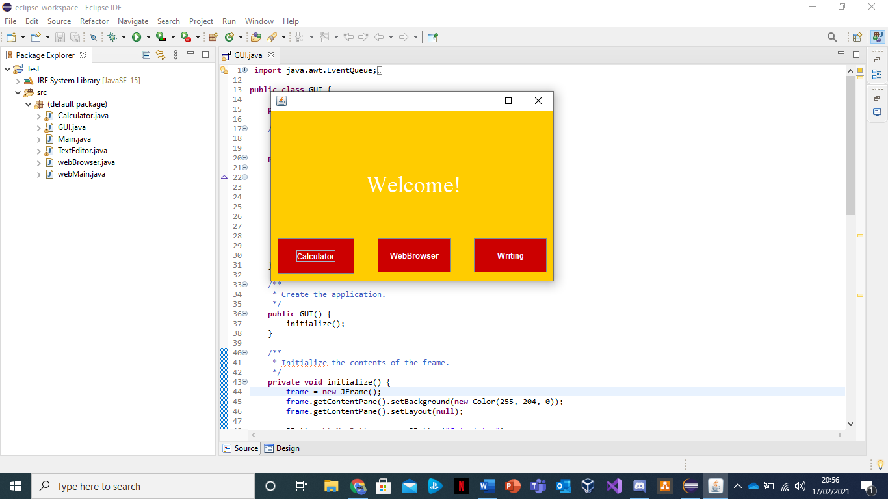As you can see here, this is the final design of what the GUI looks like with three navigational buttons to direct you to three of the aspect before.

Secondly, I will then go through web browser which was created by using ‘HTML’. The folders for the browser are split into two which they are called, ‘web browser’ and ‘Web Main’ in the screenshots below you will see what codes were used and inputted and how it runs.

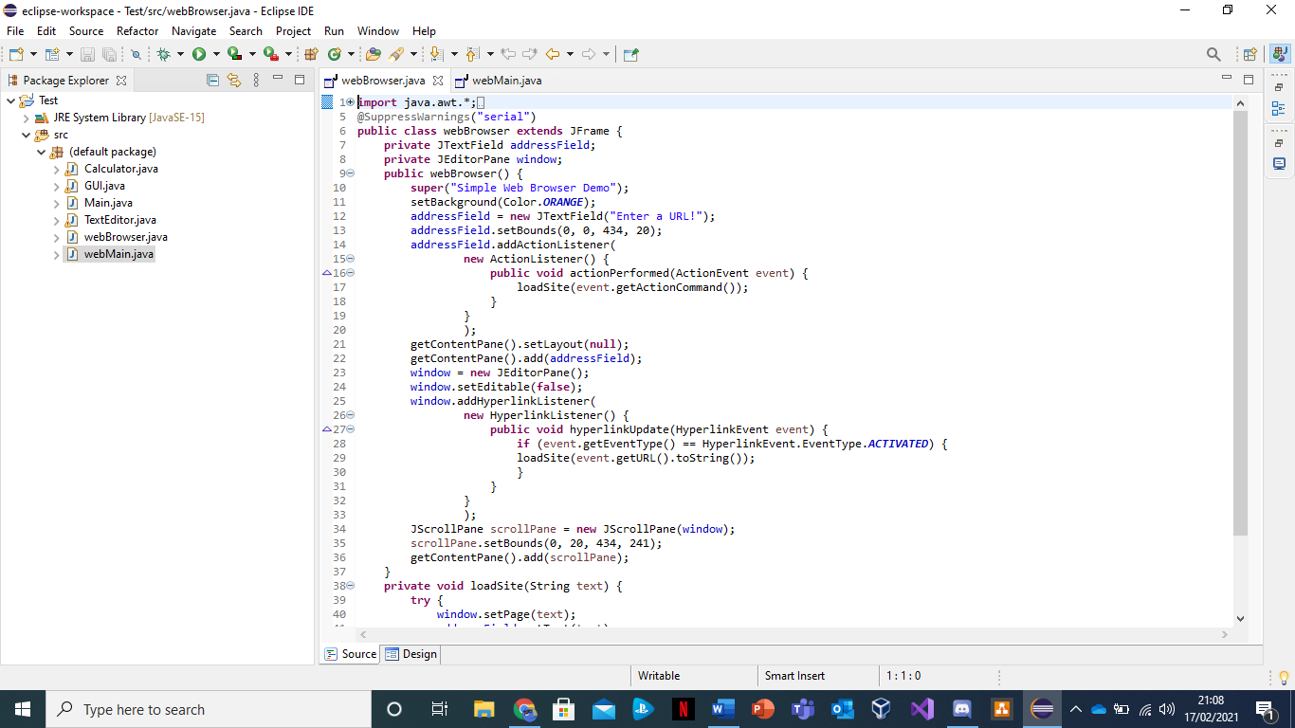

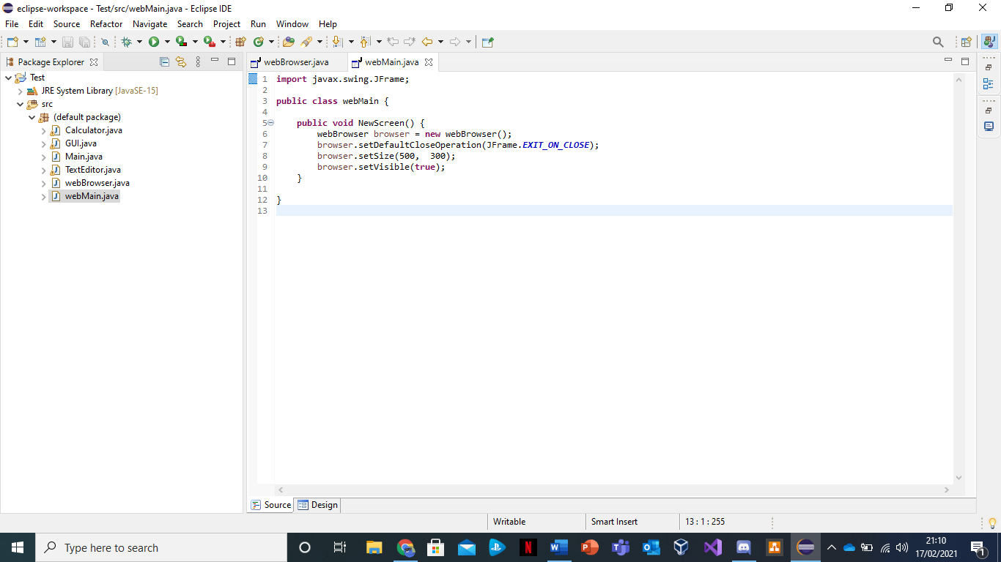As you can see here the ‘Web Browser’ programme contains the source code for the browser containing the commands that help display and create the URL. Whereas, the ‘Web Main’ programme contains the commands to help execute and launch the application. Similarly, to the GUI, by clicking the ‘run’ button (shown in the screenshot below) it displays the GUI and by clicking the middle navigational button it shows the browser or URL.

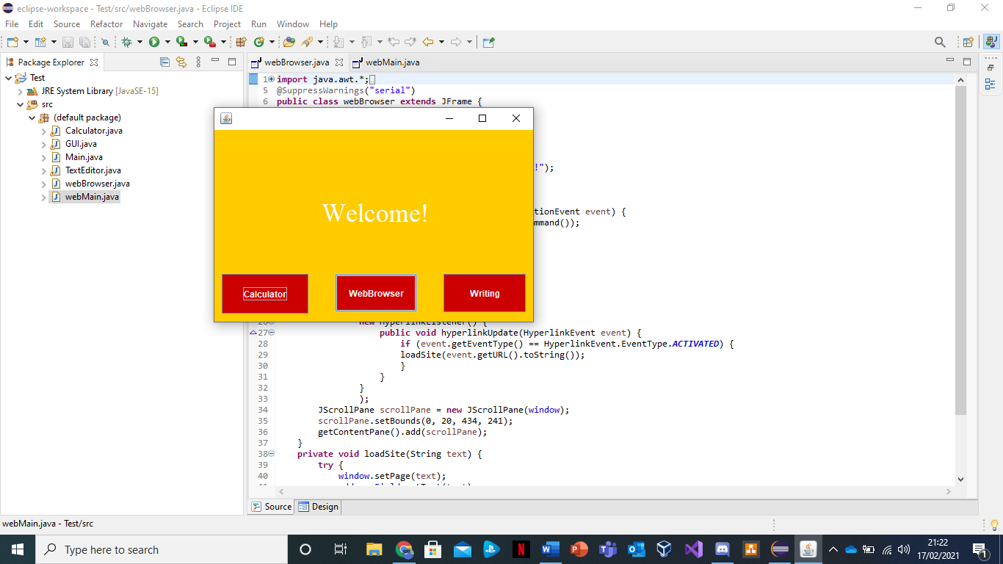

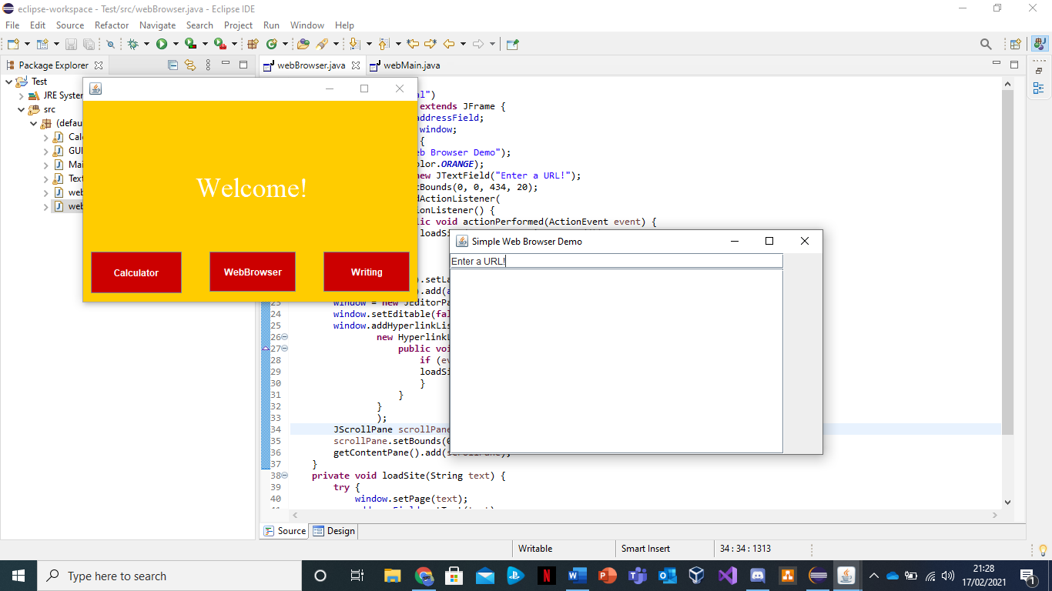Here you can see that the URL or browser comes up after you click the middle navigational button and displays on to the screen. In the screenshot below, you will see the result of the URL when you type in the web address.

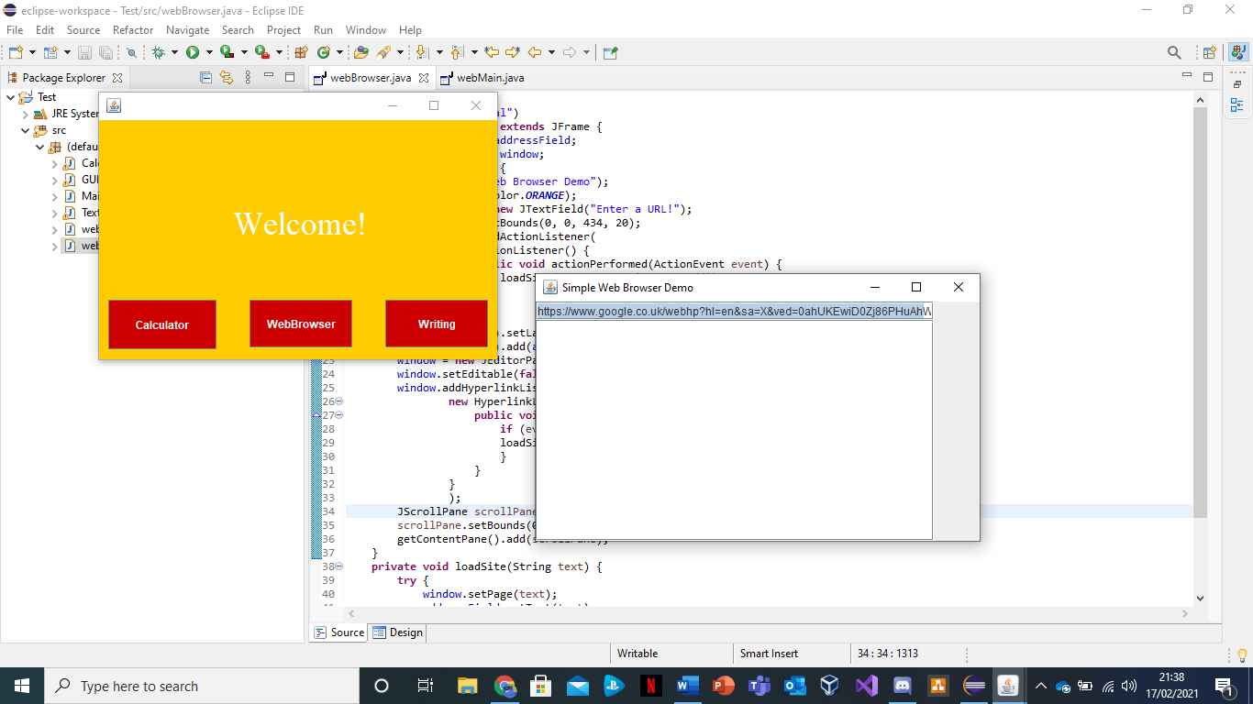

In the URL link I have typed in the web address for ‘Google’ and in the screen shot below you will see the final result.

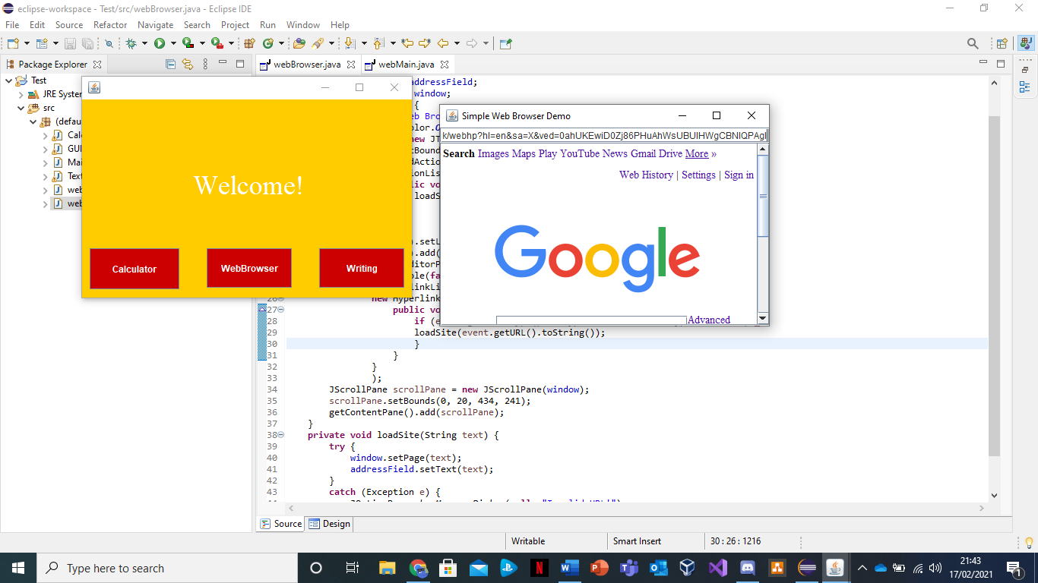Here is the final result and as it shows the URL browser works perfectly fine as the final result, the ‘Google’ search page, shows up.

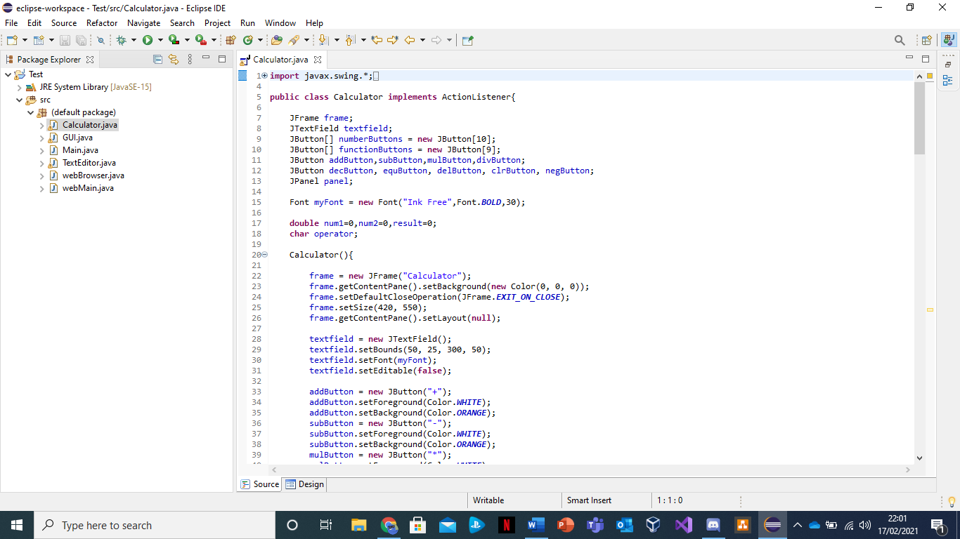Thirdly, I will now go through the second aspect of the interface which is the performing of arithmetic sums also known as the ‘Calculator’ programme and it is directed straight from the navigational button named under the word ‘Calculator’. The purpose of the calculator was to helps the students simply add, subtract, divide and multiply by clicking the buttons.

Here you can see the source codes and commands used to create and launch the calculator application. There are three key components in creating the calculator and that is the JFrame, which creates the layout, the JTextField which then displays the text and the JButton, which is then used as the main function for the calculator as it consists of the number and function buttons that basically help calculator work.

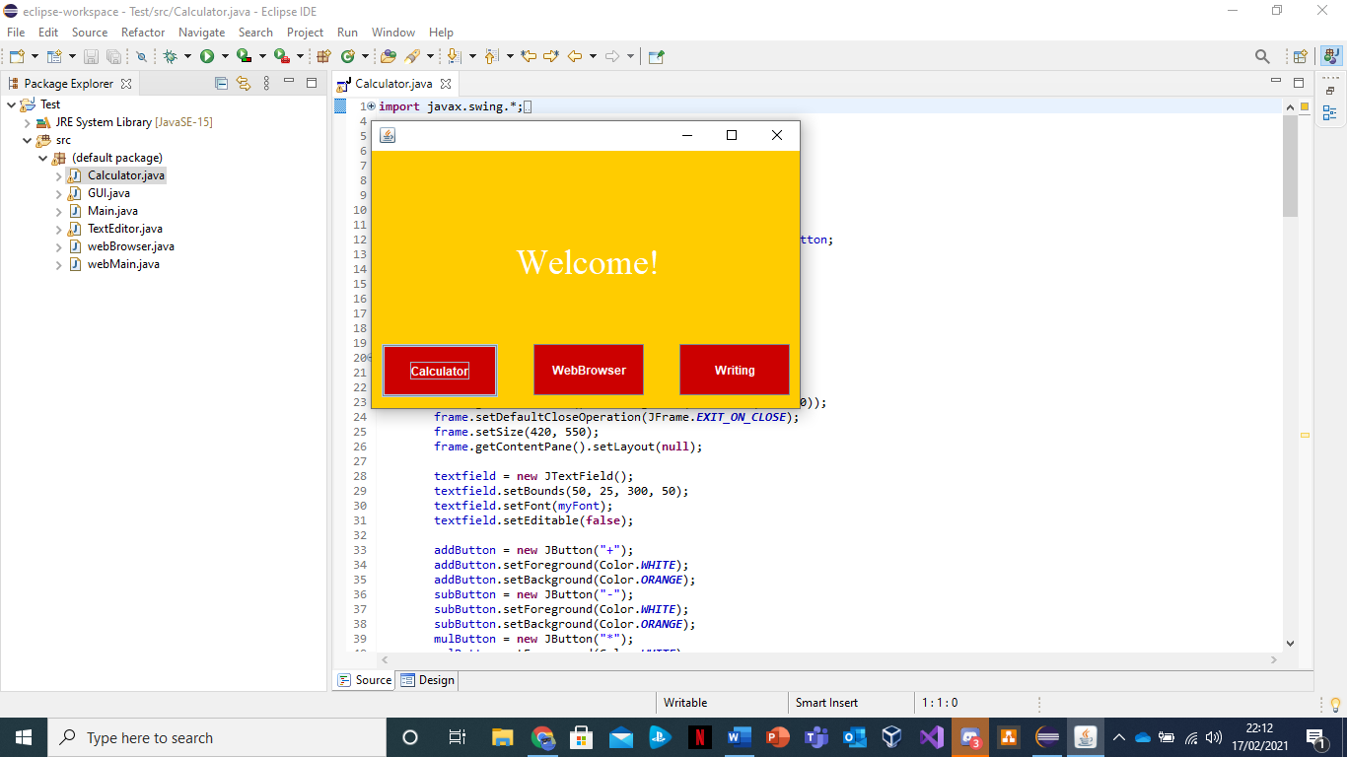

Similarly, like others the calculator is in the interface and can be accessed by clicking the ‘calculator’ navigational button. Furthermore, it can be displayed by simply clicking the button.

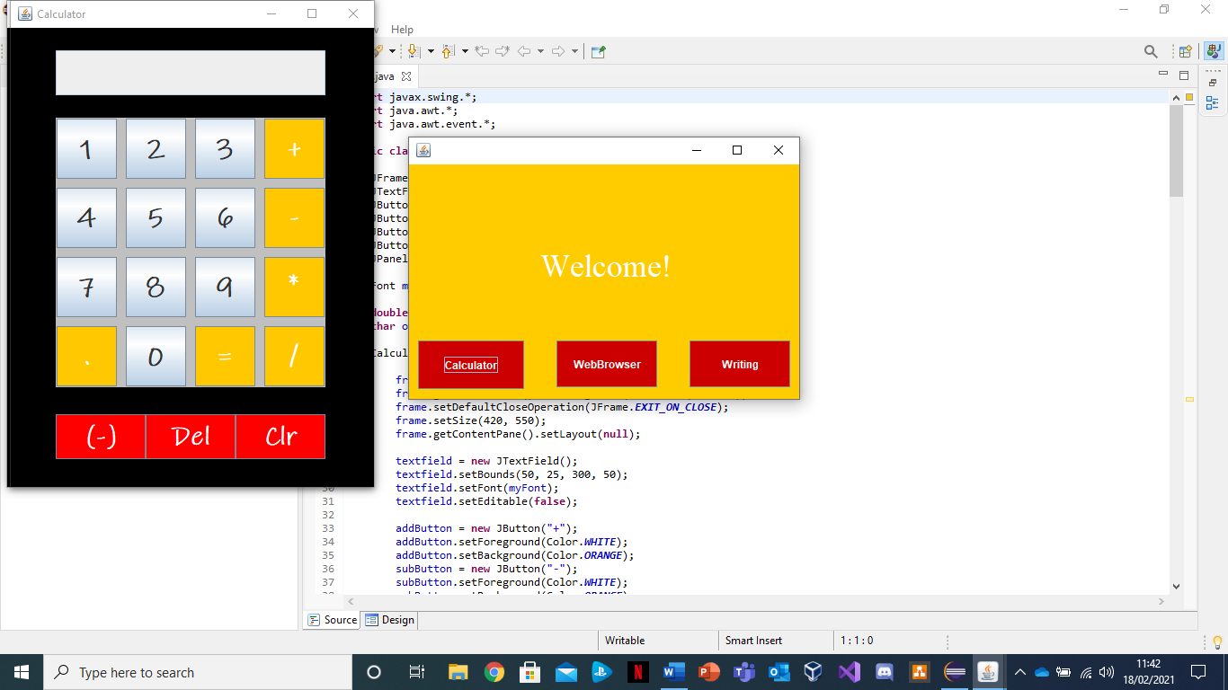

Here you can see what the calculator looks like, with it having the numbers in correct order and having the function buttons surrounding it. Moreover, you can see that it matches with the theme of the GUI as it contains the colours yellow and red with the additional black and silver. In the screenshots below you will see examples of how the calculator works.

The calculator is inputting a sum of ‘1+1’.

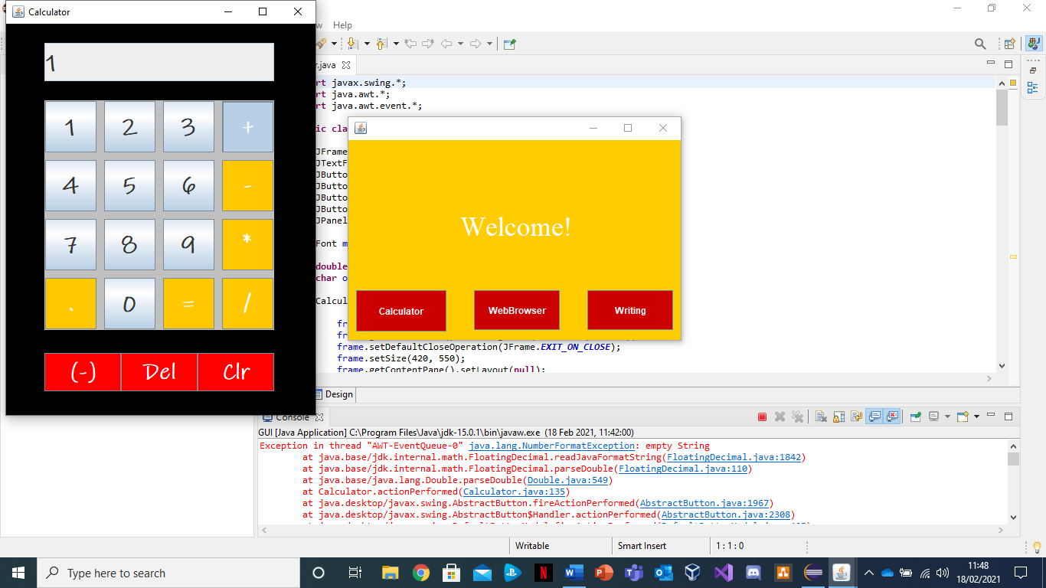

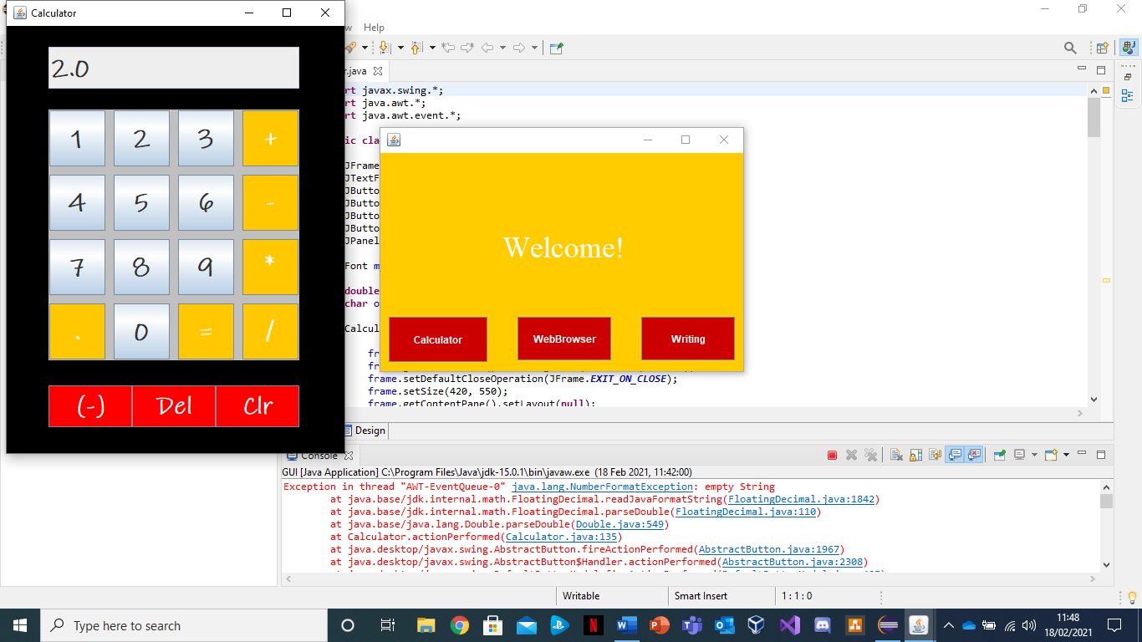

As you can see here, the calculator works perfectly because the answer comes outputs straight away with ‘2’ when you click the sum ‘1+1’.

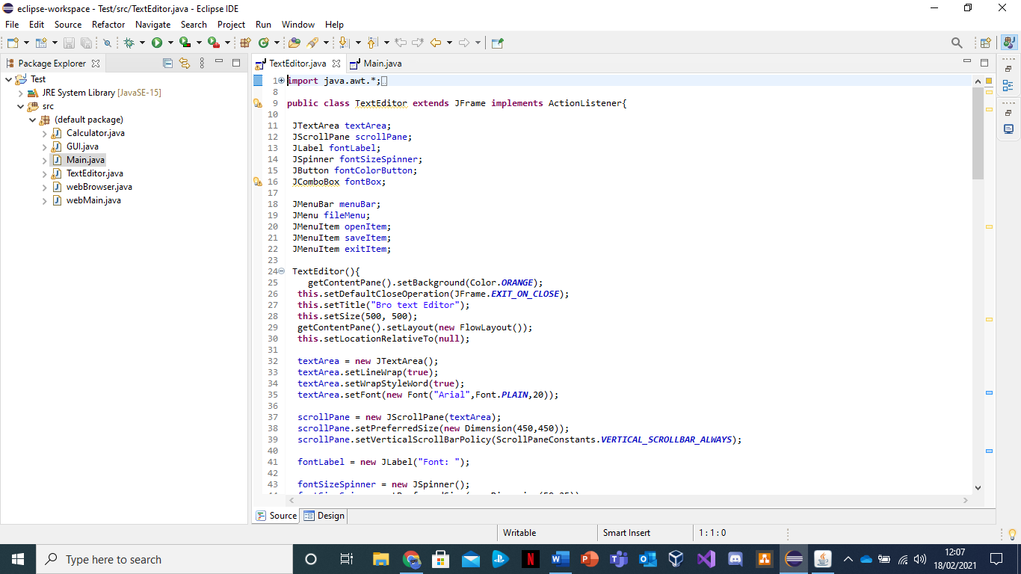Likewise, the last component we will go through is the ‘Text Editor’, which is labelled under the navigational button ‘Writing’. The source code and commands for it is split into two folders which are ‘Text Editor’, that has the main code, and the ‘Main’, which helps launch and develop the application. In the screen shot below you will the examples.

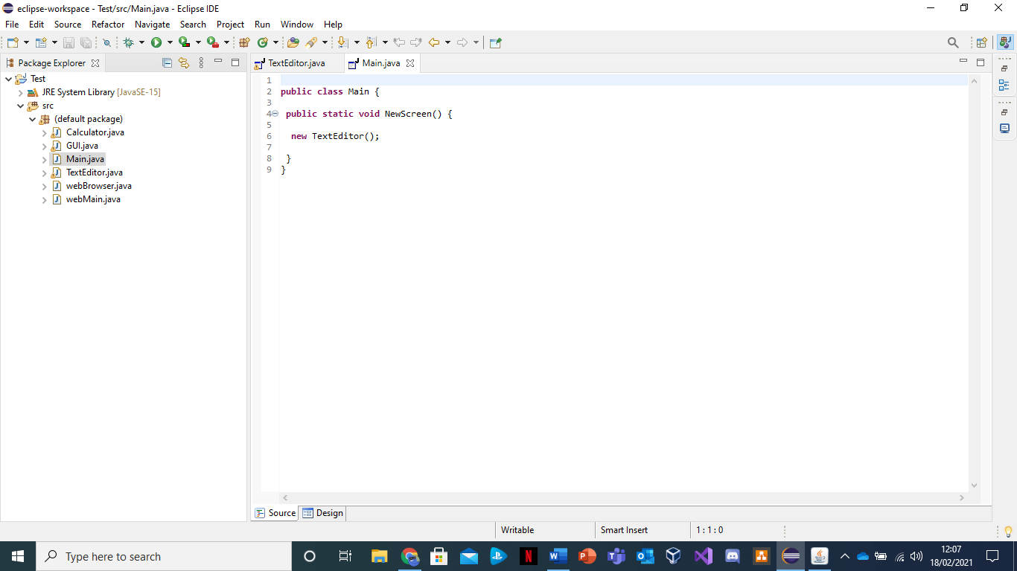

In addition to this, as mentioned before, the code and commands are split into two folders to help create and develop the application.

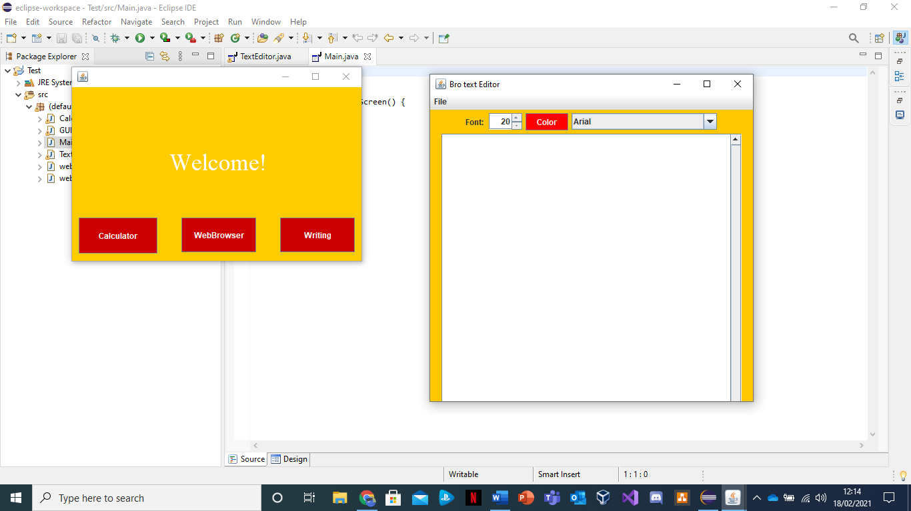

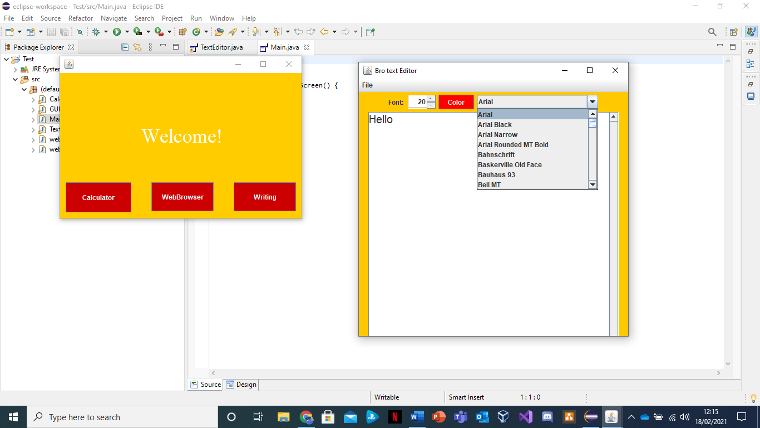

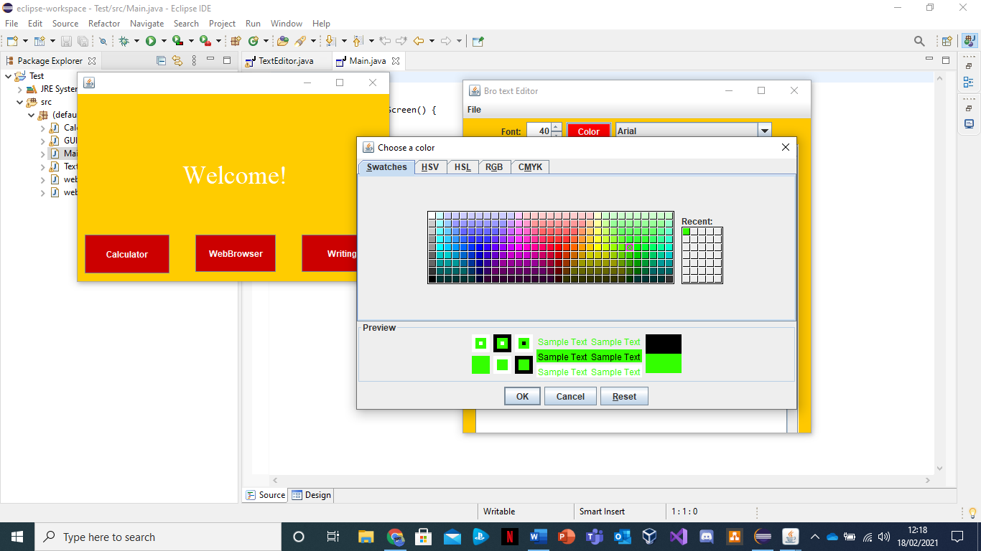

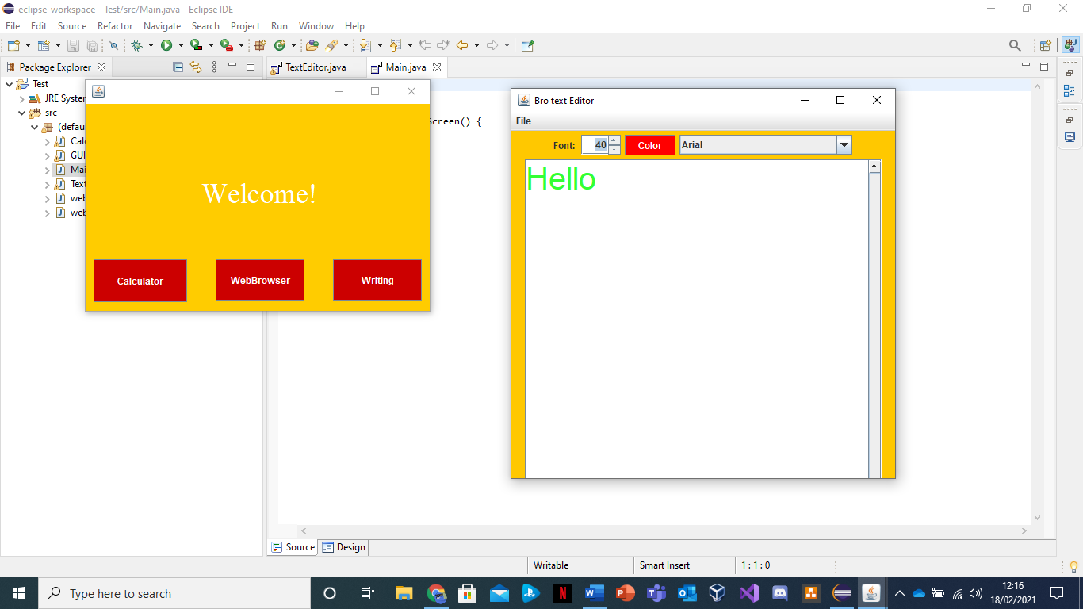

From the screenshots above, you can see that the theme and colour scheme of the editor is yellow and red which same as the rest. Furthermore, it also shows how you can change the font type, size, and colour with a simple click.

Likewise, the whole layout of GUI and applications achieved to help and assist key stage 1 students as it is simple and easy to navigate.

**Methodology**

For this project, the reason I did software testing was so that I could see if there are any faults in the source code or commands. The importance of software testing and quality assurance is of high value in a software development cycle. (Sameer, 2020). Also, I have used a ‘Window Builder’ as it was easier to design the GUI and make it more easily eye catching for the user.

**Conclusion**

In conclusion, to summarise everything, the project went well as the GUI runs perfectly as it can enable the users to navigate around the applications such as the ‘Browser’, ‘Editor’ and ‘Calculator’. All three were able to do what they are meant to which is to search, to edit and to perform simple arithmetic sums. However, there are some things that need to be improved on such as adding friendly images and banners to help gain the users attention. Likewise, the simple functions easily fit to the user’s needs.

**References**

*Sameer, S., 2020. Why Is Software Testing and QA important for any Business. [online] West Agile Labs Blog. Available at: <https://www.westagilelabs.com/blog/why-is-software-testing-and-qa-important-for-any-business/#:~:text=The%20importance%20of%20software%20testing%20and%20quality%20assurance%20is%20of,better%20usability%20and%20enhanced%20functionality.> [Accessed 18 February 2021].*